SHOW WORK! Supply units wherever applicable. Label graphs. Do not waste too much time on any one part of the exam.

Lenses

- The light source in the set-up shown below was placed at some distance to the lens and then the screen’s position was varied until an image was formed on it.
lens
screen
Light source

The data collected is contained in the following table.

Distance from light source to lens (cm) | Distance from lens to screen (cm) | The focal length of the lens (cm) | Magnification
25 | 58
30 | 42
35 | 35
40 | 31
45 | 28
50 | 27
55 | 26
60 | 25
65 | 24
 | Average ( )
 | Stand. Dev. ( )

Calculate the focal length and magnification for each trial. Calculate the average focal length as well as the standard deviation.

Copy and paste the data into Excel and make a plot of the reciprocal of the lens-screen distance versus the reciprocal of the source-lens distance. Fit it to a straight line. Paste it into this document.

PLOT GOES HERE.

Fill in the table below regarding the plot.

 | Theory | Your graph
Slope ( )
X intercept ( )
Y intercept ( )

Two-Slit Interference

- A blue laser with a wavelength of 472 nm was shone through a two-slit apparatus, which was 2.45 m from the screen/wall. The distance from the center of one fringe to the center of the fourth consecutive fringe (as shown below) was found to be 1.20 cm.

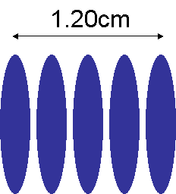

Determine the distance between the slits.

Distance between slits ( )

What would happen to the distance between the fringes if a red laser was used? Explain.

RC Circuits

- The data in the Discharge worksheet of the file p106_Practice_lab_final.xls is for a circuit with a capacitor and a resistor. Fit the data to the form appropriate for a discharging capacitor. Find the electric potential and time constant parameters. Paste the plot in this document. If the resistor has a resistance of 3.45 kΩ, then find the value of the capacitance.

PLOT GOES HERE.

Electric Potential parameter ( ):

Time constant ( ):

Capacitance ( ):

- The data in the Charge worksheet of the file p106_lab_final.xls is for a circuit with a battery (DC power supply), a capacitor and a resistor. Fit the data to the form appropriate for a charging capacitor. Find the electric potential and time constant parameters. Paste the plot in this document. If the resistor has a resistance of 2.15 kΩ, then find the value of the capacitance.

PLOT GOES HERE.

Electric Potential parameter ( ):

Time constant ( ):

Capacitance ( ):

- Capacitor C₁ was connected to a 5.00-V battery for long enough time to charge it. It was then disconnected from the battery. A second capacitor C₂ was then placed in parallel with C₁ and both were found to have voltages of 3.25 V. Determine the ratio of capacitances C₂/C₁. Show work.

How was the voltage measured?

- An experiment with capacitors was set up as shown in the figure below. Also below is a set of circuit diagrams. To which diagram does the experimental setup correspond (A, B, C, D, or E. None of these? Explain.

Corresponding diagram:

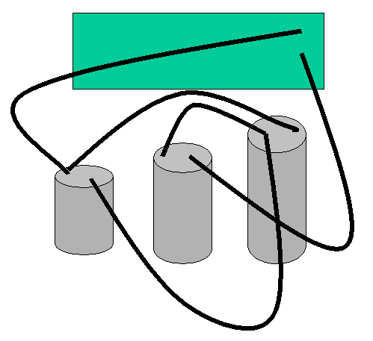

A. | B.
C. | D.

- Use the surface plot and contour plot of a charge distribution provided below to draw the electric field lines. Also indicate places on the plot where the electric potential is zero and where the electric field is zero.

